Requesting UX/UI for Travel Ease Holidays Website

- Email: info@traveleaseholidays.com
- Contact: +94 11 2695454
- WhatsApp: +94 777347542

Main Menu: Home, About Us, Services, Tours, Contact Us
Header Menu: Payments, Blogs
Eg: Header Menu 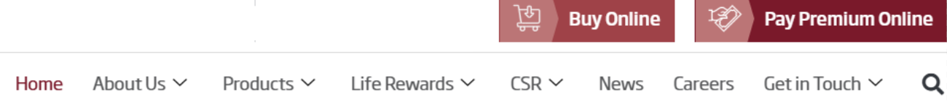 Main Menu

- The theme should contain Travel ease colours.
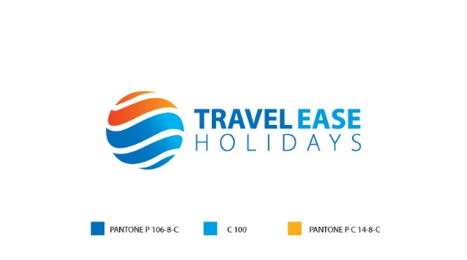
- Use a dotted line to be continue from top to bottom as a journey.
- The home page includes sections: Trending tour packages | gallery | review | why choose us | A section with Sri Lankan map with attractions | A section with Tour types,
Home page hero section 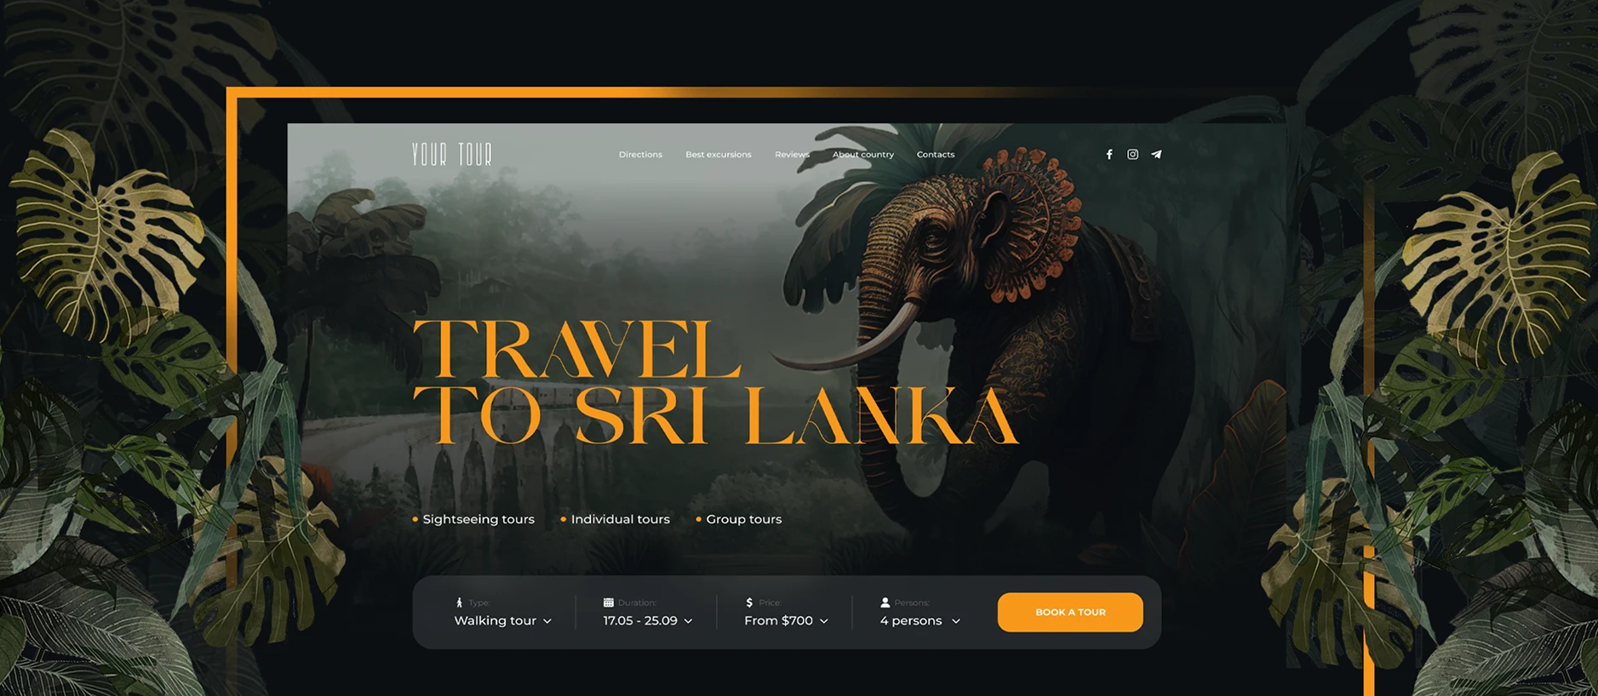
- Header details should be same as travel channel- replacing contents of travel ease
- Instead of still image, add a video to Hero section
- Search bar should be there
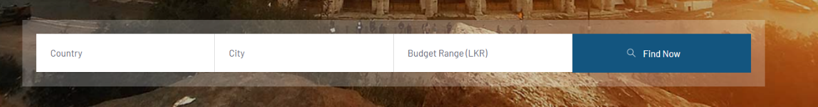
- Search bar should be as : Type | Duration | Book now button
Home page prioritized packages
Beach_Relaxation | Wildlife_Nature | Experience | Honeymoon
………………………………………………………………………………………………………………………………………………
Services
Tour packages | Hotel | Transfers | Experience | Mice | ETA visa
Tours
Adventure | Beach_Relaxation | Culture_Heritage | Food_Taste | Wildlife_Nature | Young_Trendy | Experience | Family | Honeymoon | Pilgrimage

Footer
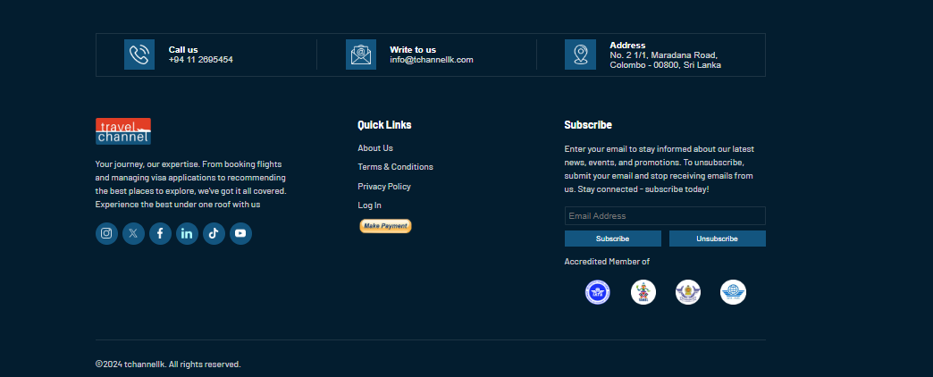
- Similar footer should be placed with travel ease wordings.
- There should be a place where you can send us inquires for other tours
- Last at the bottom; mention: Brought to you by Travel Channel
- All the other details should be as travel channel replacing wordings matching to travel ease holidays.

About us
We will provide the content. Link this to home page “Why choose us section”

Online Payment
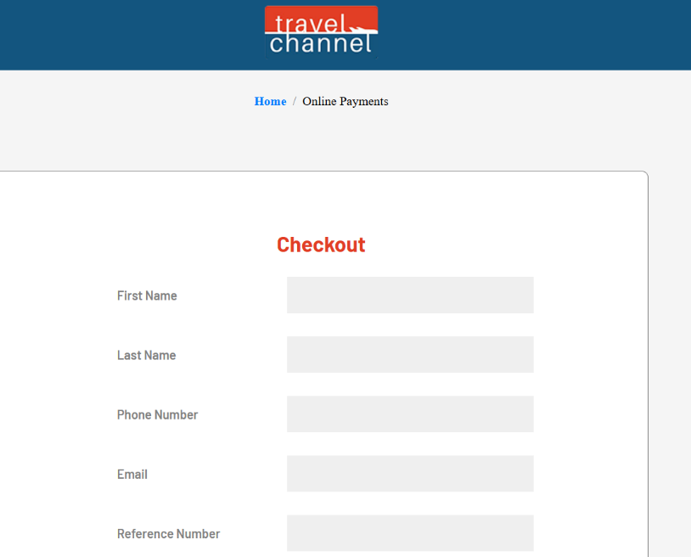
- Redesign the interface

Contact us
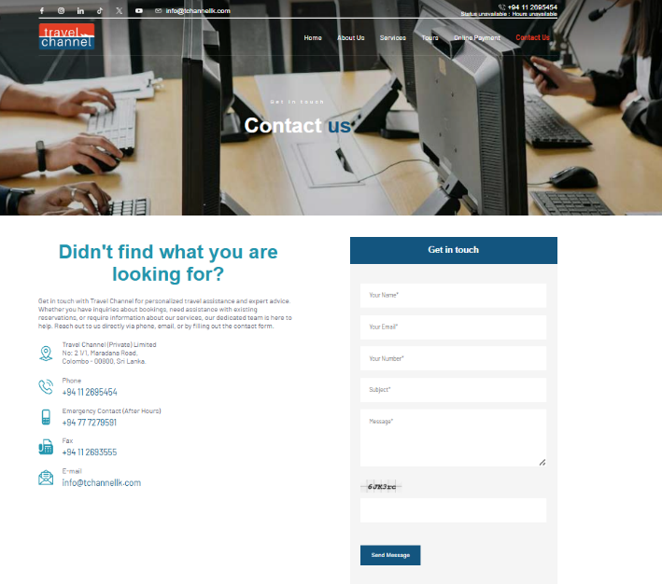
- Same as travel channel

Journal (Blogs)
The blog pages should include images, and geo locations
In Frame (Gallery)
An image gallery with attractions of Sri Lanka:
Eg: Kandy perahara, whale watching, Yala safari photos, some photos from our experience tours
We should have access to upload recent photos

Archive Pages: Show case of tour packages
Tour Package: Include Itinerary, price, inclusions, inclusion with icons, exclusions, tour duration, tour highlights, inquiry form, and other general inclusions in tour packages, Google map location,
Refer to this as a reference
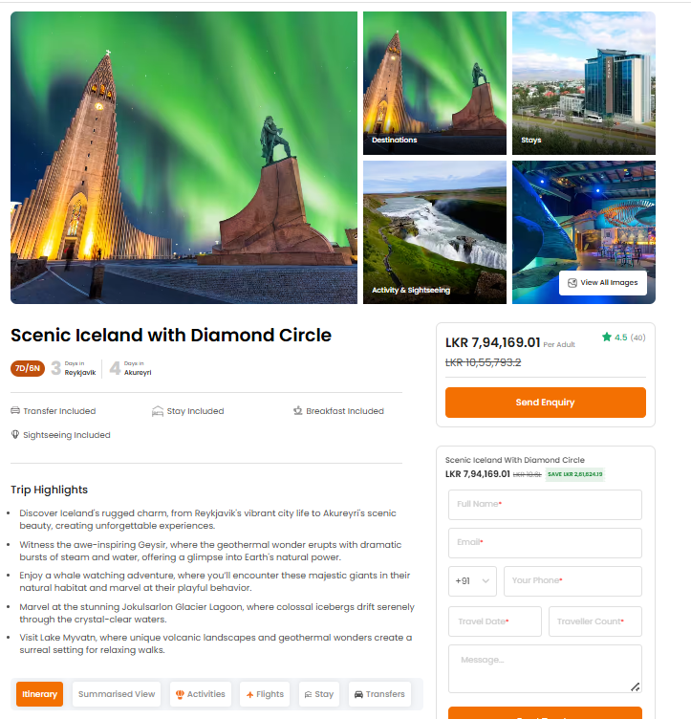
General:
- Call to action button in every page
- Language change option
- Currency convertor

